**Lab 2**

**Question 1**

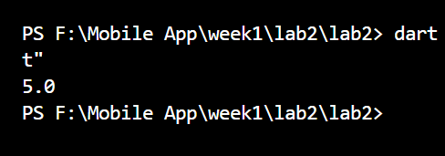

Question 2

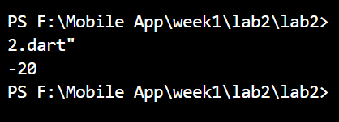

Question 3

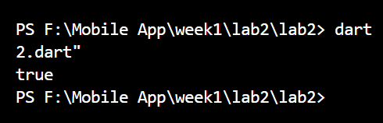

Question 4

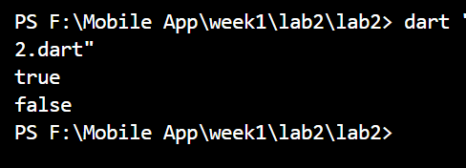

Question 5

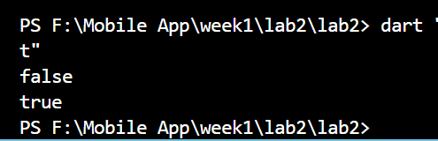

Quesiton 6

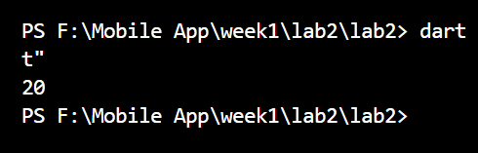

Question 7

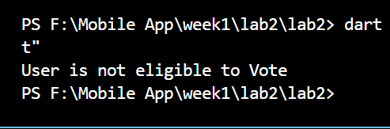

Question 8



Question 9

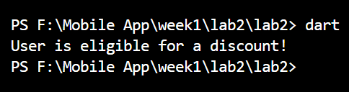

Question 10

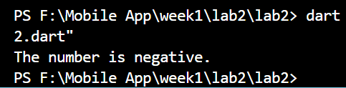

Question 11

